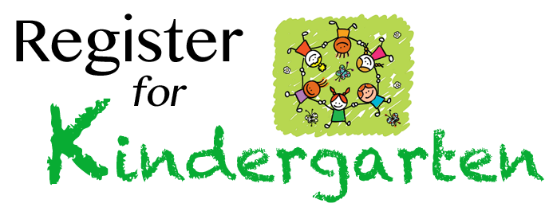
Kindergarten Enrollment for 2017/2018, Due to limited class size, enrollment will be on a first come first serve basis. There is a $75.00 non-refundable enrollment fee for each child. Children must turn five before September 1 to enroll.
This is a Three Day Program – Tuesday, Thursday, and Friday. Hours 9:45am-2:30pm. The cost will be $255 a month. This amount is due the first school day of each month beginning in September and ending in May.
Children will engage in play, crafts, curriculum, Bible stories, Kid fit, Chapel, Music and so much more!
We will work closely with Moore Schools to achieve objectives and Report Card standards.
Our primary Kindergarten teacher will be licensed and certified in the State of Oklahoma. We have two scheduled parent/ teacher conferences during the school year. However, teachers are always available to discuss progress and concerns.

Childs Name_________________________DOB_____________________
Parent Name_______________________PHONE#___________________
Email________________________________________________________

_______________________________________________________________
To be filled out by Director
Deposit Amount________Cash______or Check #_________ Date_______

